CS 514 Applied Artificial Intelligence Project 2 report

A BLOOD SUGAR DETERMINING EXPERT SYSTEM

FUZZY DIABETES DIAGNOSER

INDEX

|  |  |
| --- | --- |
| Topic | Page number |
| Abstract | 3 |
| Features | 3 |
| Rules and Descriptions | 4 |
| Fuzzification Of The Data | 6 |
| Usage Manual | 6 |
| Sample runs | 7 |

***Note:*** *Suitable links have been provided for additional information wherever necessary in RULES and DESCRIPTION.*

# Abstract:

Diabetes Diagnoser is a rule based expert system built on JESS that is designed to take certain biochemistry related parameters from the user’s blood test and infer certain vital parameters to diagnose diabetes and makes recommendations to the user of the system. The system advices user on workout and food intake plans based on the various components in the person’s biochemistry. The system is also capable of recommending any further tests required by the user based on the ratio of glucose, electrolytes and lipid profiles . To determine blood sugar level the system considers the Fasting blood glucose and Post prandial blood glucose.

# Features:

1. The system requires the patient’s blood test details like the Fasting blood glucose, Post prandial blood glucose, Electrolytes and Lipid profiles.
2. The system considers the result of every biochemical component and advises the user if further steps are required.
3. The system first analyses the blood glucose level before as well as after the intake of food.
4. It then checks the various electrolyte levels like sodium, potassium, chlorides and creatinine. Then it advices the user on further steps to be taken if these components are found to be either high or low.
5. The system also analyses the lipid profiles present in the user’s bio chemistry.
6. The lipid profiles include Cholesterol, HDL Cholesterol, Triglycerides, non-HDL Cholesterol, VLDL Cholesterol. Except, HDL Cholesterol all other Cholesterol are dangerous for health. If there is an increase in the level of these cholesterols above the normal range then the system advices the user on the necessary actions to be taken.
7. The system is also capable of identifying that the high levels of HDL cholesterol is beneficial for health and encourages it.
8. The system advices the user to undergo BUN test if the urea in the blood is high as this might cause kidney problems.
9. The system recommends regular exercise, if the user has high cholesterol.
10. The system determines if the user has high sugar, low sugar or no sugar based on the Fasting blood glucose and Post prandial blood glucose levels.
11. All the attributes considered in biochemistry are independent. Hence, will not have any influence on each other.

# Rules and descriptions:

There are 2 templates described in the code:

**Biochemistry**

(deftemplate biochemistry

(slot fasting_blood_glucose(type float))

(slot post_prandial_blood_glucose(type float))

(slot serum_sodium(type float))

(slot serum_potassium(type float))

(slot serum_chloride(type float))

(slot HbAlc(type float))

(slot blood_urea(type float))

(slot serum_creatinine(type float))

(slot cholestrol(type float))

(slot HDL_Cholestrol(type float))

(slot direct_LDL(type float))

(slot S_Triglycerides(type float))

(slot Non_HDL_Cholestrol (type float))

(slot VLDL_Cholestrol (type float))

(slot sample (type integer))

)

**Patient**

(deftemplate patient

(slot name)

(slot age(type integer))

(slot sex)

(slot diabetes_in_family)

**Fuzzy Template**

(deftemplate fasting_blood_glucose_data

"Auto-generated"

(declare (ordered TRUE)))

(deftemplate post_prandial_blood_glucose_data

"Auto-generated"

(declare (ordered TRUE)))

(deftemplate Age_data

"Auto-generated"

(declare (ordered TRUE)))

(deftemplate Cholesterol_data

"Auto-generated"

(declare (ordered TRUE)))

(deftemplate Sample_data

"Auto-generated"

(declare (ordered TRUE)))

(deftemplate chol_sample

"Auto-generated"

(declare (ordered TRUE)))

(deftemplate age_sample

"Auto-generated"

(declare (ordered TRUE)))

(deftemplate Triglycerides

    "Auto-generated"

    (declare (ordered TRUE))

    )

(deftemplate Triglycerides_sample

    "Auto-generated"

    (declare (ordered TRUE))

    )

(deftemplate Physical_Activity_Mins

    "Auto-generated"

    (declare (ordered TRUE))

    )

(deftemplate Physical_Activity_Mins_sample

    "Auto-generated"

    (declare (ordered TRUE))

    )

(deftemplate Blood_Pressure

    "Auto-generated"

    (declare (ordered TRUE))

    )

(deftemplate Blood_Pressure_sample

    "Auto-generated"

    (declare (ordered TRUE))

    )

(deftemplate Blood_Urea

    "Auto-generated"

    (declare (ordered TRUE))

    )

(deftemplate Blood_Urea_sample

    "Auto-generated"

    (declare (ordered TRUE))

    )

There are total 31 rules in the program:

|  |  |  |  |
| --- | --- | --- | --- |
| **#** | **Rule Name** | **Description** | **References and detailed explanations** |
| 1 | initial | Prints all the information in the test report. |  |
| 2 | defrule Low_Sugar | Checks if both the fasting and post prandial glucose is low. | [0-70](https://en.wikipedia.org/wiki/Body_mass_index) mg/dl  0-65 mg/dl |
| 3 | defrule High_Sugar | Checks if both the fasting and post prandial glucose is high. | [80-190](https://en.wikipedia.org/wiki/Body_mass_index) mg/dl  115-300 mg/dl |
| 4 | defrule Medium_Sugar | Checks if both the fasting and post prandial glucose is medium. | [55-110](https://en.wikipedia.org/wiki/Body_mass_index) mg/dl  50-155 mg/dl |
| 5 | defrule Low_High_Sugar | Checks if the fasting glucose is low and post prandial glucose is high. | [0-70](https://en.wikipedia.org/wiki/Body_mass_index) mg/dl  115-300 mg/dl |
| 6 | defrule High_Low_Sugar | Checks if the fasting glucose is high and post prandial glucose is low. | [80-190](https://en.wikipedia.org/wiki/Body_mass_index) mg/dl  0-65 mg/dl |
| 7 | defrule Low_Medium_Sugar | Checks if the fasting glucose is low and post prandial glucose is medium. | [0-70](https://en.wikipedia.org/wiki/Body_mass_index) mg/dl  50-155 mg/dl |
| 8 | defrule Medium_Low_Sugar | Checks if the fasting glucose is medium and post prandial glucose is low. | [55-110](https://en.wikipedia.org/wiki/Body_mass_index) mg/dl  0-65 mg/dl |
| 9 | Defrule High_Medium_Sugar | Checks if the fasting glucose is high and post prandial glucose is medium. | [80-190](https://en.wikipedia.org/wiki/Body_mass_index) mg/dl  50-155 mg/dl |
| 10 | defrule Medium_High_Sugar | Checks if the fasting glucose is medium and post prandial glucose is high. | [55-110](https://en.wikipedia.org/wiki/Body_mass_index) mg/dl  115-300 mg/dl |
| 11 | defrule Low_Cholesterol | Checks if the Cholesterol levels are low | 0-65mg/dl |
| 12 | defrule High_Cholesterol | Checks if the Cholesterol levels are high. | 50-155mg/dl |
| 13 | defrule Medium_Cholesterol | Checks if the Cholesterol levels are medium. | 115-300mg/dl |
| 14 | defrule Low_Age | Checks if the patient is young. | 0-25 years |
| 15 | defrule Medium_Age | Checks if the patient is middle aged. | 20-70 years |
| 16 | defrule High_Age | Checks if the patient is Old. | 55-100 years |
| 17 | defrule Low_Triglycerides | Check if Triglycerides levels are low | >150 mg/dl |
| 18 | defrule Med_Triglycerides | Check if Triglycerides levels are Medium | 150 – 199 mg/dL |
| 19 | defrule high_Triglycerides | Check if Triglycerides levels are High | 200-499 mb/dL |
| 20 | defrule Low_Physical_Activity | Check if Physical activity levels are low | 0-10 minutes |
| 21 | defrule Med_Physical_Activity | Check if Physical activity levels are Medium | 10-40 minutes |
| 22 | defrule high_Physical_Activity | Check if Physical activity levels are High | 40-120 minutes |
| 23 | defrule Low_Blood_Pressure | Check if Blood Pressure levels are low | >80 |
| 24 | defrule Med_Blood_Pressure | Check if Blood Pressure levels are Medium | 80-120 |
| 25 | defrule high_Blood_Pressure | Check if Blood Pressure levels are High | <120 |
| 26 | defrule Low_Blood_Urea | Check if Blood Urea levels are low | >7 mg/dL |
| 27 | defrule Med_Blood_Urea | Check if Blood Urea levels are Medium | 7-20 mg/dL |
| 28 | defrule high_Blood_Urea | Check if Blood Urea levels are High | <7 mg/dL |
| 29 | defrule diagnose | To determine if the person has diabetes based on the data provided. |  |
| 30 | defrule printFacts | To print all the facts |  |
| 31 | defrule init | Initialize the values for the patient and his biochemistry |  |
|  |  |  |  |
|  |  |  |  |

# Fuzzification Of The Data :

# The MAIN:: init - Fuzzy variables rule is used to divide the Fasting blood glucose, Post prandial blood glucose, Cholesterol and Age into desirable fuzzy categories with the following template:

(?*fasting_blood_glucose_Var* addTerm "low" (new ZFuzzySet 10.0 70.0))

(?*fasting_blood_glucose_Var* addTerm "medium" (new TrapezoidFuzzySet 55.0 70.0 85.0 110.0))

(?*fasting_blood_glucose_Var* addTerm "High" (new SFuzzySet 80.0 190.0))

# Once the fuzzification is complete, the user defined values for the applicant template are passed into the rule so that they are categorized accordingly and used further ahead. This process is done using:

(assert (fasting_blood_glucose_data (new FuzzyValue ?*fasting_blood_glucose_Var* (new SingletonFuzzySet ?biochemistry.fasting_blood_glucose))))

# Finally, the rule that was defined for Boolean logic in project 1 can now be divided into all possible sub categories that deal with all the fuzzy sets accordingly.

# Usage Manual:

## Instructions:

Copy the file diabetes_diagnosis.clp to the BIN folder under the JESS directory.

Open JESS and execute the below commands:

(batch AI_Blood_Sugar1.clp)

# Sample runs:

## Run #1

Condition where the user do not have diabetes or any other risks.

(assert (biochemistry(fasting_blood_glucose 55.0)

(post_prandial_blood_glucose 115.0)

(serum_sodium 50.0)

(serum_potassium 2.0)

(serum_chloride 80)

(HbAlc 5)

(blood_urea 10)

(serum_creatinine 0.5)

(cholestrol 150)

(HDL_Cholestrol 30)

(direct_LDL 70)

(S_Triglycerides 50)

(Non_HDL_Cholestrol 80)

(VLDL_Cholestrol 25)

))

(assert (patient (name "Mark")

(age 45)

(sex "Male")

(diabetes_in_family "Y")))

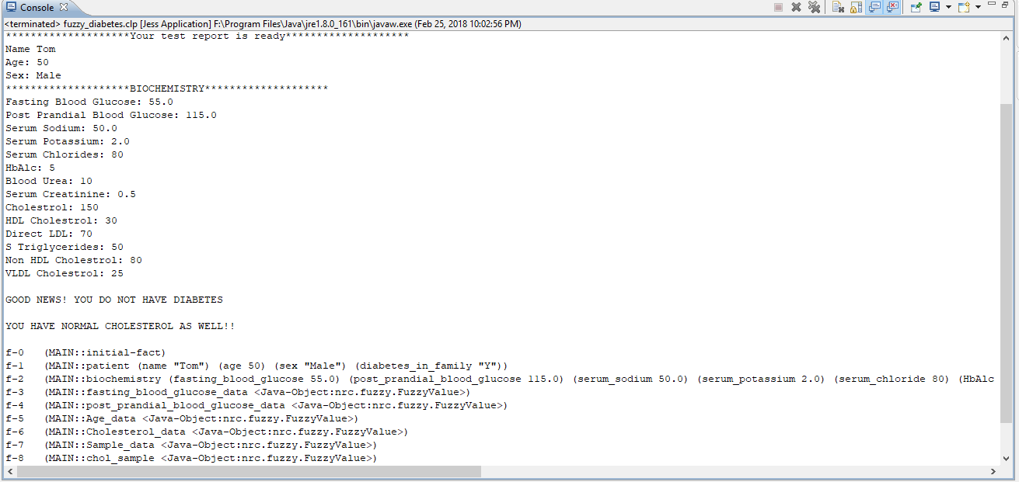

## Run #2

Condition where the user has high diabetes and other risks.

(assert (biochemistry(fasting_blood_glucose 150.0)

(post_prandial_blood_glucose 250.0)

(serum_sodium 50.0)

(serum_potassium 2.0)

(serum_chloride 80)

(HbAlc 5)

(blood_urea 10)

(serum_creatinine 0.5)

(cholestrol 150)

(HDL_Cholestrol 30)

(direct_LDL 70)

(S_Triglycerides 220)

(Non_HDL_Cholestrol 80)

(VLDL_Cholestrol 25)

)))

(assert (patient (name "Mark")

(age 45)

(sex "Male")

(diabetes_in_family "Y")))

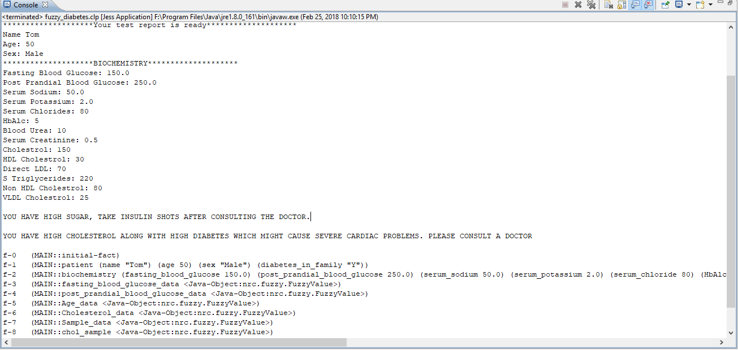

## Run #3

Condition where the user has low blood sugar and other risks.

(assert (biochemistry(fasting_blood_glucose 50.0)

(post_prandial_blood_glucose 45.0)

(serum_sodium 50.0)

(serum_potassium 2.0)

(serum_chloride 80)

(HbAlc 5)

(blood_urea 10)

(serum_creatinine 0.5)

(cholestrol 150)

(HDL_Cholestrol 30)

(direct_LDL 70)

(S_Triglycerides 250)

(Non_HDL_Cholestrol 80)

(VLDL_Cholestrol 25)

))

(assert (patient (name "Mark")

(age 45)

(sex "Male")

(diabetes_in_family "Y")))

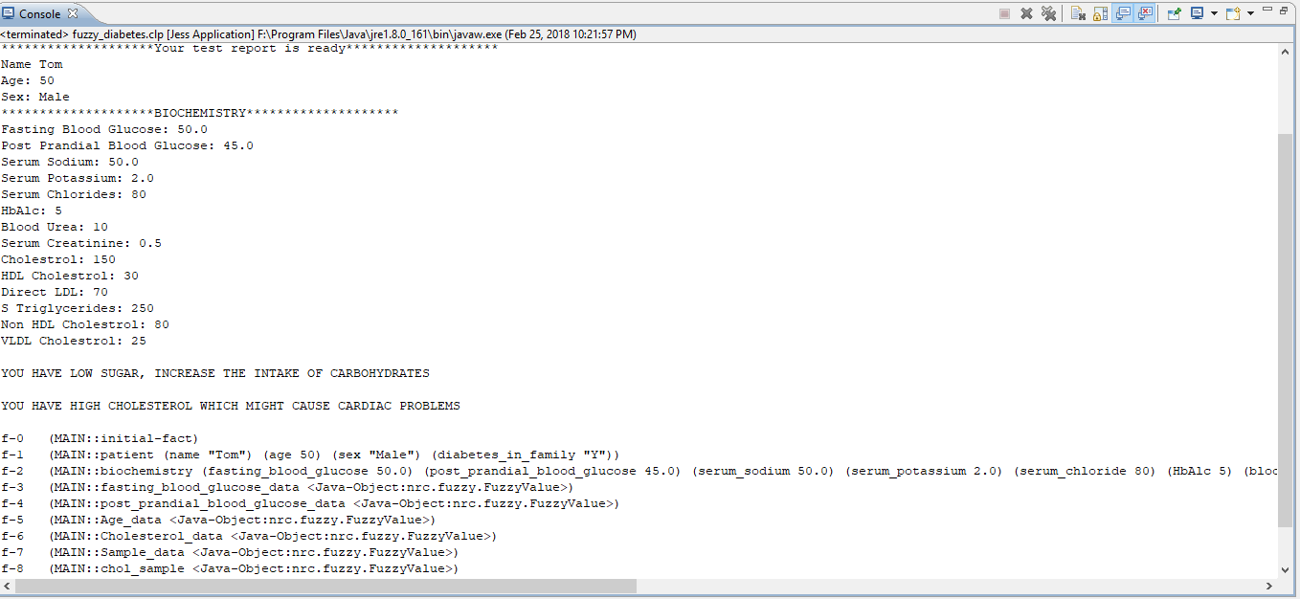

## Run #4

Condition where the user is prediabetic and has other problems.

(assert (biochemistry(fasting_blood_glucose 75.0)

(post_prandial_blood_glucose 110.0)

(serum_sodium 50.0)

(serum_potassium 2.0)

(serum_chloride 80)

(HbAlc 5)

(blood_urea 10)

(serum_creatinine 0.5)

(cholestrol 150)

(HDL_Cholestrol 30)

(direct_LDL 70)

(S_Triglycerides 250)

(Non_HDL_Cholestrol 80)

(VLDL_Cholestrol 25)))

(assert (patient (name "Mark")

(age 45)

(sex "Male")

(diabetes_in_family "Y")))

